GOVERNMENT OF INDIA
MINISTRY OF COMMERCE & INDUSTRY
OFFICE OF ECONOMICS ADVISER
Index Numbers of Wholesale Price in India (Base: 2011-12=100)
Review for the month of March, 2020

The official Wholesale Price Index for 'All Commodities' (Base: 2011-12=100) for the month of March, 2020 declined by 0.90% to 121.1 (provisional) from 122.2 (provisional) for the previous month.
INFLATION
The annual rate of inflation, based on monthly WPI, stood at 1.00% (provisional) for the month of March, 2020 (over March, 2019) as compared to 2.26% (provisional) for the previous month and 3.10% during the corresponding month of the previous year. Build up inflation rate in the financial year so far was 1.00% compared to a build up rate of 3.10% in the corresponding period of the previous year.
Inflation for important commodities / commodity groups is indicated in Annex-1 and Annex-II. The movement of the index for the various commodity group is summarized below:-
PRIMARY ARTICLES (Weight 22.62%)
The index for this major group declined by 2.5% to 139.5 (provisional) from 143.1 (provisional) for the previous month. The groups and items which showed variations during the month are as follows:-
The index for 'Food Articles' group declined by 2.1% to 151.6 (provisional) from 154.9 (provisional) for the previous month due to lower price of egg (17%), poultry chicken (9%), tea (7%), fish-marine, maize and fruits & vegetables (5% each), jowar (4%), bajra and wheat (3% each), gram, paddy, betel leaves and urad (2% each) and fish-inland, arhar, pork, masur and mutton (1% each). However, the price of beef and buffalo meat (8%), moong and peas/chawali (4% each) and ragi and milk (1% each) moved up.
The index for 'Non-Food Articles' group declined by 4.2% to 126.1 (provisional) from 131.6 (provisional) for the previous month due to lower price of floriculture (30%), safflower (kardi seed) (12%), soyabean and gaur seed (8% each), sunflower (7%), raw rubber (4%), linseed, coir fibre, rape & mustard seed and hides (raw) (2% each) and niger seed, copra (coconut), raw jute and castor seed (1% each). However, the price of cotton seed (6%), groundnut seed (5%), skins (raw) (3%) and industrial wood, raw silk, fodder and gingelly seed (sesamum) (1% each) moved up.
The index for 'Minerals' group rose by 4.2% to 153.8 (provisional) from 147.6 (provisional) for the previous month due to higher price of manganese ore (15%), copper concentrate (7%) and phosphorite (6%). However, the price of chromite (3%), limestone (2%) and bauxite, zinc concentrate and lead concentrate (1% each) declined.
The index for 'Crude Petroleum & Natural Gas' group declined by 6.6% to 81.3 (provisional) from 87.0 (provisional) for the previous month due to lower price of crude petroleum (9%).
FUEL & POWER (Weight 13.15%)
The index for this major group declined by 3.1% to 100.7 (provisional) from 103.9 (provisional) for the previous month. The groups and items which showed variations during the month are as follows:-
The index for 'Mineral Oils' group declined by 5.6% to 87.2 (provisional) from 92.4 (provisional) for the previous month due to lower price of ATF (19%), naphtha (13%), HSD and kerosene (5% each), petrol and furnace oil (4% each) and LPG (3%). However, the price of petroleum coke (7%) moved up.
MANUFACTURED PRODUCTS (Weight 64.23%)
The index for this major group remained unchanged at its previous month level of 118.7. The groups and items which showed variations during the month are as follows:-

The index for ‘Manufacture of Food Products’ remained unchanged to its previous level of 136.9. The items which decreased where rice bran extract (9%), rice bran oil (3%), cotton seed oil cake (2%) and gur, rapeseed oil, gram powder (Besan), honey, chicken/duck, dressed- fesh/frozen, palm oil, maida, gola & similar cattle feed, sunflower oil, vegetable starch, rice products and cotton seed oil (1% each). However, the price of molasses (6%), coffee powder with chicory (4%), spices (including mixed spices) (3%), groundnut oil, fish frozen/canned/processed and mustard oil cake (2% each) and processed tea, vanaspati, mustard oil, bagasse, sooji (rawa), sugar confectionary, rice non-basmati, corn flake and ice cream (1% each) moved up.
The index for 'Manufacture of Tobacco Products' group rose by 0.4% to 154.8 (provisional) from 154.2 (provisional) for the previous month due to higher price of other tobacco products (1%). However, the price of cigarette (1%) declined.
The index for 'Manufacture of Textiles' group declined by 0.1% to 116.6 (provisional) from 116.7 (provisional) for the previous month due to lower price of manufacture of knitted and crocheted fabrics (1%). However, the price of viscose yarn (2%) moved up.
The index for 'Manufacture of Wearing Apparel' group rose by 0.1% to 138.0 (provisional) from 137.8 (provisional) for the previous month due to higher price of manufacture of wearing apparel (woven), except fur apparel (1%). However, the price of manufacture of knitted and crocheted apparel (1%) declined.
The index for 'Manufacture of Leather and Related Products' group rose by 0.1% to 117.9 (provisional) from 117.8 (provisional) for the previous month due to higher price of harness, saddles & other related items (2%) and chrome tanned leather and waterproof footwear (1% each). However, the price of travel goods, handbags, office bags, etc. and plastic/PVC chappals (1% each) declined.
The index for 'Manufacture of Wood and of Products of Wood and Cork ' group rose by 0.2% to 133.0 (provisional) from 132.7 (provisional) for the previous month due to higher price of wooden box/crate (2%). However, the price of wood cutting, processed/sized (1%) declined.
The index for 'Manufacture of Paper and Paper Products' group rose by 0.3% to 120.3 (provisional) from 120.0 (provisional) for the previous month due to higher price of pulp board (4%), corrugated sheet box (3%), tissue paper (2%) and card board and corrugated paper board (1%). However, the price of laminated plastic sheet (4%) and paper carton/box (2%) declined.
The index for 'Printing and Reproduction of Recorded Media ' group rose by 1.2% to 153.3 (provisional) from 151.5 (provisional) for the previous month due to higher price of printed books (2%) and hologram (3d) and journal/periodical (1% each).
The index for 'Manufacture of Chemicals and Chemical Products' group declined by 0.2% to 115.8 (provisional) from 116.0 (provisional) for the previous month due to lower price of mono ethyl glycol (10%), ammonia gas (9%), sulphuric acid (8%), polystyrene, expandable (4%), organic solvent and catalysts (3% each), superphospate/phosphatic fertilizer, others, alkyl benzene, other inorganic chemicals, poly propylene (PP) and camphor (2% each) and carbon black, ammonium phosphate, aniline (including PNA, ONA, OCPNA), organic chemicals, shampoo, ethyl acetate, additive and adhesive excluding gum (1% each). However, the price of nitric acid (9%), hydrogen peroxide (6%), oleoresin, agarbatti, menthol and safety matches (match box) (2% each) and phthalic anhydride, toilet soap, viscose staple fibre, ammonium nitrate, caustic soda (sodium hydroxide), gelatine, polyester fibre fabric, varnish (all types), fatty acid , poly vinyl chloride (PVC), liquid air & other gaseous products, foundry chemical, explosive, di ammonium phosphate and mixed fertilizer (1% each) moved up.
The index for 'Manufacture of Pharmaceuticals, Medicinal Chemical and Botanical Products' group rose by 0.2% to 130.6 (provisional) from 130.3 (provisional) for the previous month due to higher price of vials/ampoule, glass, empty or filled (5%), simvastatin (2%) and API & formulations of vitamins, antioxidants, anti-malarial drugs and antibiotics & preparations thereof (1% each). However, the price of antidiabetic drug excluding insulin (i.e. tolbutam) (6%) and anti-retroviral drugs for HIV treatment (2%) declined.
The index for 'Manufacture of Other Non-Metallic Mineral Products' group rose by 0.2% to 116.5 (provisional) from 116.3 (provisional) for the previous month due to higher price of stone, chip (6%), porcelain sanitary ware (3%), slag cement and cement superfine (2% each) and granite, toughened glass and fibre glass incl. sheet (1% each). However, the price of electric insulating material (2%) and non ceramic tiles, white cement, marble slab, ceramic tiles (vitrified tiles), ordinary sheet glass, railway sleeper, lime and calcium carbonate and clinker (1% each) declined.
The index for 'Manufacture of Basic Metals' group declined by 0.4% to 106.6 (provisional) from 107.0 (provisional) for the previous month due to lower price of stainless steel pencil ingots/billets/slabs (5%), MS pencil ingots and pig iron (2% each) and hot rolled (HR) coils & sheets, including narrow strip and steel forgings - rough (1% each). However, the price of rails (6%), ferrosilicon (4%), stainless steel coils, strips & sheets (3%), aluminium disk and circles (2%) and cast iron, castings, angles, channels, sections, steel (coated/not), brass metal/sheet/coils, stainless steel bars & rods, including flats and ferrochrome (1% each) moved up.
The index for 'Manufacture of Fabricated Metal Products, Except Machinery and Equipment' group rose by 0.1% to 114.7 (provisional) from 114.6 (provisional) for the previous month due to higher price of forged steel rings and cylinders (2% each) and steel drums and barrels and steel container (1% each). However, the price of sanitary fittings of iron & steel (8%), jigs & fixture (5%), bracket (2%) and hand tools and hose pipes in set or otherwise (1% each) declined.
The index for 'Manufacture of Computer, Electronic and Optical Products' group declined by 0.2% to 109.3 (provisional) from 109.5 (provisional) for the previous month due to lower price of electronic printed circuit board (PCB)/micro circuit (4%) and x-ray equipment (2%). However, the price of electro-diagnostic apparatus, used in medical, surgical, dental or veterinary sciences (4%) moved up.
The index for 'Manufacture of Electrical Equipment' group rose by 0.9% to 111.7 (provisional) from 110.7 (provisional) for the previous month due to higher price of transformer (6%), cooling tower (2%) and jelly filled cables and electric welding machine (1% each). However, the price of fibre optic cables (3%), safety fuse (2%) and electric mixers/grinders/food processors, electric filament type lamps, flourescent tube, rubber insulated cables and AC motor (1% each) declined.
The index for 'Manufacture of Machinery and Equipment' group declined by 0.4% to 112.9 (provisional) from 113.4 (provisional) for the previous month due to lower price of air or vacuum pump (4%), air gas compressor including compressor for refrigerator and roller and ball bearings (3% each), manufacture of bearings, gears, gearing and driving elements, pharmaceutical machinery, mining, quarrying & metallurgical machinery/parts and dumper (2% each) and hydraulic equipment (1%). However, the price of gasket kit (7%) and excavator (1%) moved up.
The index for 'Manufacture of Motor Vehicles, Trailers and Semi-Trailers' group rose by 0.5% to 115.4 (provisional) from 114.8 (provisional) for the previous month due to higher price of minibus/bus (4%) and head lamp and cylinder liners (1% each). However, the price of brake pad/brake liner/brake block/brake rubber, others (3%), chassis of different vehicle types (2%) and piston ring/piston and compressor (1%) declined.
The index for 'Manufacture of Furniture' group rose by 2.1% to 130.9 (provisional) from 128.2 (provisional) for the previous month due to higher price of foam and rubber mattress (14%). However, the price of hospital furniture (7%) and wooden furniture (1%) declined.
The index for 'Other Manufacturing' group rose by 0.5% to 117.6 (provisional) from 117.0 (provisional) for the previous month due to higher price of gold & gold ornaments (1%) and cricket bat (1%). However, the price of silver (6%), cricket ball (2%) and sports goods of rubber (incl. balls) (1%) declined.

WPI FOOD INDEX (Weight 24.38%)

The rate of inflation based on WPI Food Index consisting of ‘Food Articles’ from Primary Articles group and ‘Food Product’ from Manufactured Products group decreased from 7.31% in February, 2020 to 5.49% in March, 2020.

FINAL INDEX FOR THE MONTH OF JANUARY, 2020 (BASE YEAR:2011-12=100)
For the month of January, 2020 the final Wholesale Price Index for 'All Commodities' (Base: 2011-12=100) stood at 123.4 as compared to 122.9 (provisional) and annual rate of inflation based on final index stood at 3.52% as compared to 3.10% (provisional) respectively as reported on 14.02.2020.

Next date of press release: 14/05/2020 for the month of April, 2020
Office of Economic Adviser, Ministry of Commerce & Industry, New Delhi,
This press release is available at our home page http://eaindustry.nic.in

Note: Due to outbreak of Coronavirus and Nationwide lockdown, the provisional figures of WPI for latest month are computed with low response rate. The figures are likely to be revised in a significant manner during release of final month.

Annexure-I
Wholesale Price Index and Rates of Inflation (Base Year: 2011-12=100)
Month of March, 2020

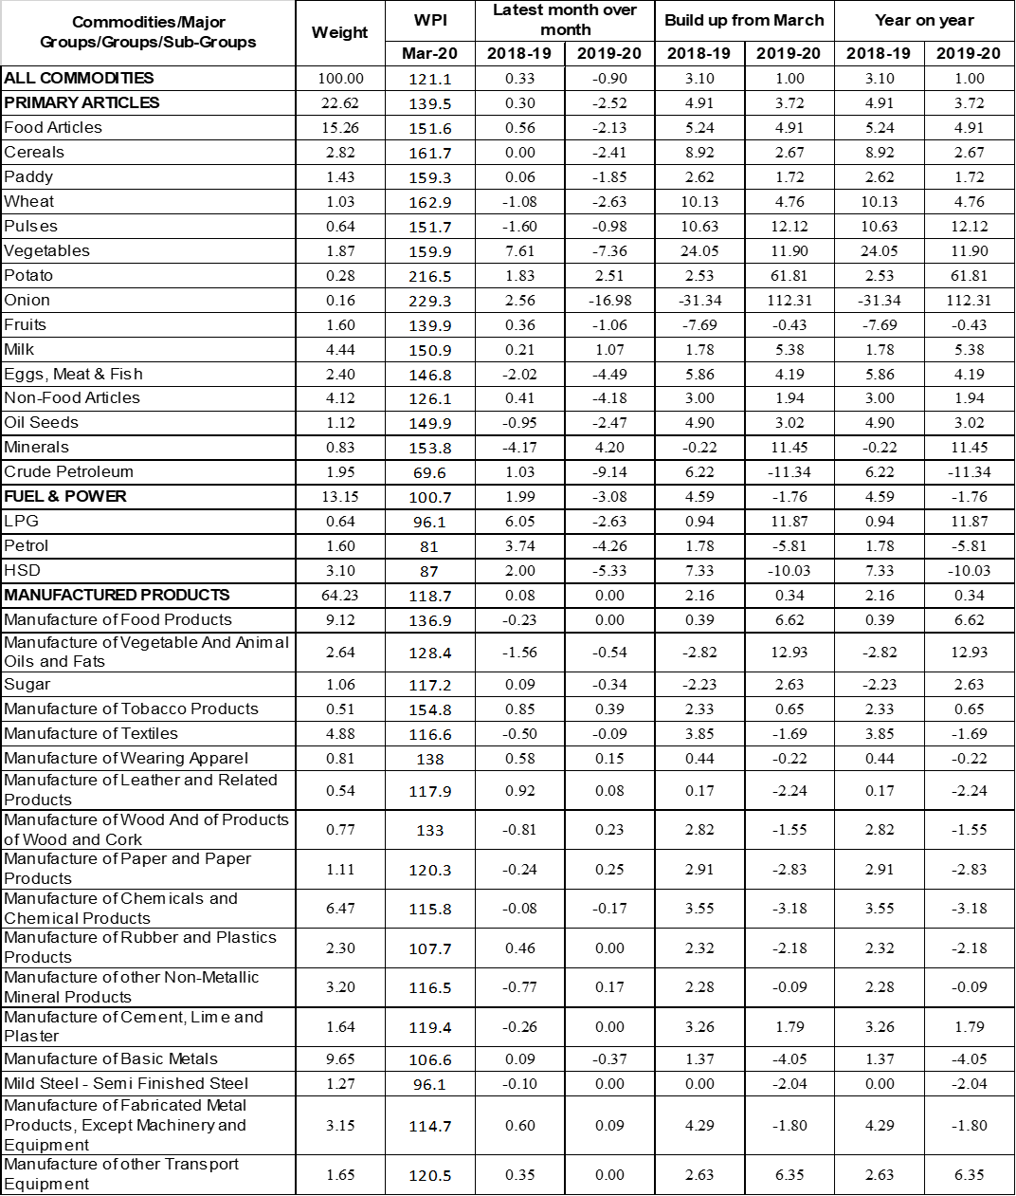

Annexure-II



